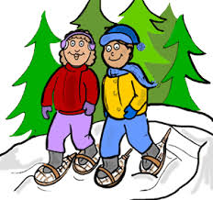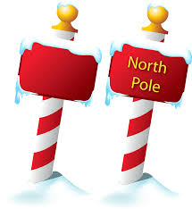 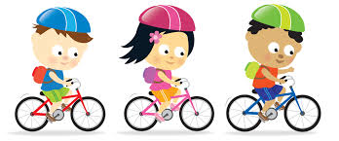

The North Pole is where Santa Claus spends all year round making presents for all the good girls and boys.

Let’s make the journey to visit Santa Claus for Christmas.

Let’s Walk to the North

Pole

**LET’S GET PHYSICALLY ACTIVE TOGETHER!**

I see the North Pole in your “Future.” Just remember you are one step closer to “FINISHING YOUR GOAL.” Have fun and get involved in physical activity.

Remember you have one MONTH to accomplish your goal. Keep track of your physical activity by using the calendar.

## The North Pole

The journey to the North Pole is about 3,890 miles from Mason County. Each class will be considered a group so each student in the group will be given Fit bits to monitor their physical activity. The Fit bit will monitor every step that you will take. The number of steps taken will then be calculated from steps to miles. It’s very important that you keep track of your miles. Each group will add their miles together to get a total number of miles that the group has walked. Once your group reaches 3,890 you have completed the journey to the North Pole! Also, encourage your family to help you complete your journey.

* Dance
* Jump rope
* Biking
* Hiking
* Walking
* Running
* Climbing
* Play catch
* Join a team
* Play tag
* Hopscotch
* Gymnastics

### Fun way’s to get Physically Activity

# Let’s Get Moving!