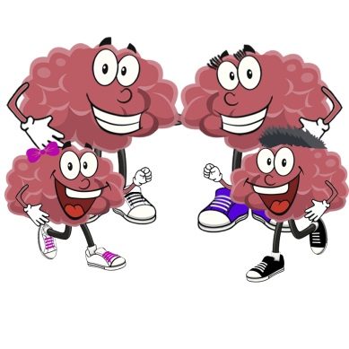
Barriers to Being Active Quiz

Please read each statement and indicate if this describes your family.
Your Activate! leader will review this with your family after completion.
 | Yes | No
- Our day is so busy now; we just don’t think we can make the time to include physical activity in our regular schedule.
- None of our family members or friends likes to do anything active, so we don’t have a chance to exercise.
- We are just too tired after work and school to get any exercise.
- We have been thinking about getting more exercise, but we just can’t seem to get started.
- We have a fear of getting injured.
- We do not get enough exercise because we have never learned the skills for any sport.
- We don’t have access to jogging trails, swimming pools, bike paths, etc.
- Physical activity takes too much time away from other commitments—like work, family etc.
- We are embarrassed about how we will look when we exercise with others.
- We don’t get enough sleep as it is. We just couldn’t get up early or stay up late to get some exercise.
- It’s easier for us to find excuses not to exercise than to go out and do something.
- We know too many people who have hurt themselves by overdoing it with exercise.
- We really can’t see learning a new sport at this point in our life.
- It’s just too expensive. You have to take a class or join a club or buy the right equipment.
- Our free times during the day are too short to include exercise.
- Our usual social activities with family or friends do not include physical activity.
- We are too tired during the week and need the weekend to catch up on our rest.
- We want to get more exercise, but we just can’t seem to make ourselves stick to anything.
- We are afraid we might injure ourselves or have a heart attack.
- We are not good enough at any physical activity to make it fun.
- If we had exercise facilities at work and school, then we would be more likely to exercise.

