What did you like about this activity? What would you share with others?

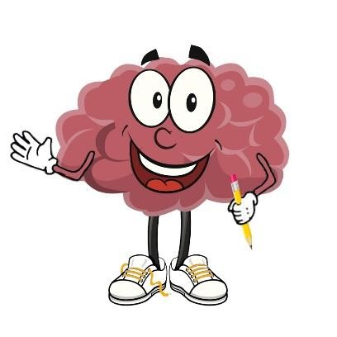

Thinking

Back

and Looking Forward

What is Your Story?

Now that you have finished this Activate! session.

!

What did you like about this activity? What would you share with others?

What would you tell yourself and your family if you started all over again? What advice would you give?